📊 Executive Sales Deck
High-Budget Automation Programs (7–10+ Million SAR)
Mohammed Al-Ojaimi Energy Services – Automation Department
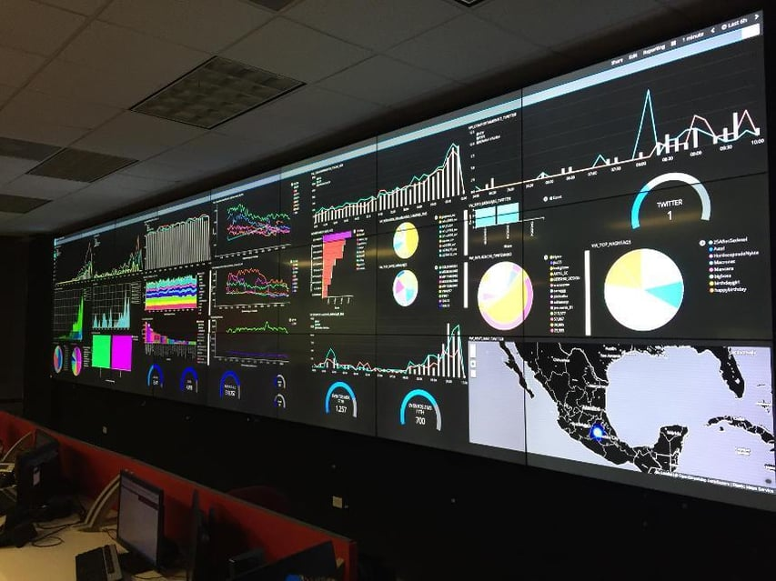
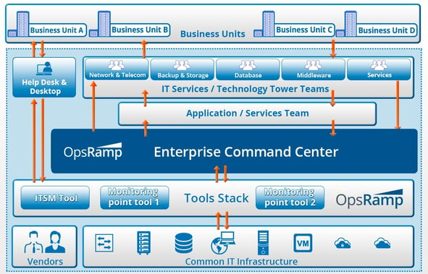
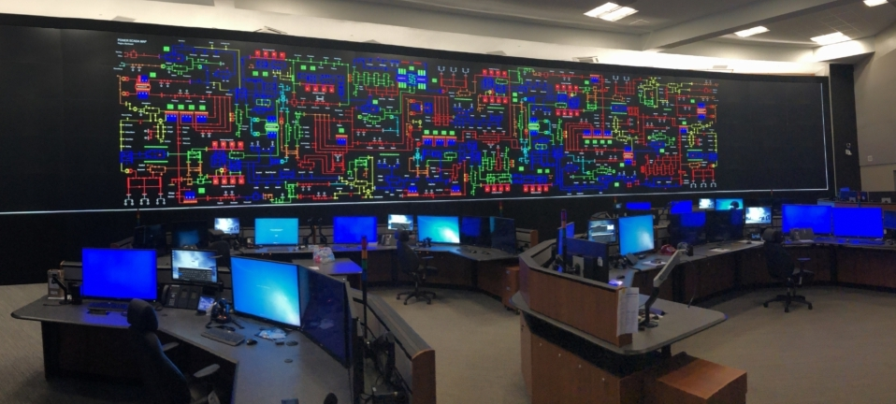
4

Slide 1 — Executive Opening
Utility-Grade Automation for Mission-Critical Operations
From power grids to factories, hospitals, and mega facilities
We engineer automation platforms where failure is not an option.
This is not an automation project.
It is an operational resilience investment.

Slide 2 — The Executive Reality
Across industrial, medical, and enterprise facilities:
- Downtime = direct financial loss
- Fragmented systems = blind operations
- Alarm overload = slow response
- Energy waste = uncontrolled OPEX
- Vendor lock-in = future risk
Most automation projects fail at scale because they were never engineered as critical infrastructure.

Slide 3 — Our Strategic Differentiator
Utility-Grade Engineering Discipline
We bring methodologies proven in:
- National power utilities
- Control centers
- Mission-critical OT environments
Applied to:
- Industrial factories
- Medical cities
- Mega buildings & data centers
Result: deterministic behavior, predictable performance, long lifecycle value.

Slide 4 — What We Actually Deliver
An Operations Backbone, Not Isolated Systems
A centralized Operations & Intelligence Platform built on COPA-DATA zenon, integrating:
- Power & energy systems
- Production / facility automation
- Utilities & infrastructure
- Alarm & event intelligence
- Analytics & KPIs
One platform. One operational truth.

Slide 5 — Target Use Cases
✔ Industrial & process factories
✔ Medical cities & hospitals
✔ Data centers & mega buildings
✔ Airports, campuses, mixed-use developments
Typical engagement size:
7 – 10+ Million SAR (scaling to 25–50+ M SAR)

Slide 6 — Business Value (Board-Level)
KPI | Typical Improvement
Asset Availability | >99.99%
Unplanned Downtime | −30% to −50%
Energy Cost | −10% to −20%
Alarm Noise | −50% to −70%
Decision Latency | Hours → Minutes
ROI is delivered through avoided losses, not theoretical savings.

Slide 7 — Financial Justification
Why This Is a CAPEX-Justified Program
- Downtime avoidance pays back within 24–36 months
- Energy optimization delivers recurring annual savings
- Reduced vendor dependency lowers long-term OPEX
- Scalable architecture avoids re-engineering costs
This platform becomes part of the asset value, not an expense.

Slide 8 — Why Al-Ojaimi Automation
- Proven utility-grade automation heritage
- Deep expertise in power, OT networks, redundancy
- Vendor-agnostic, future-proof designs
- Strong execution governance (EPC / PMC aligned)
- Single accountable partner for large programs
We are engineers first — integrators second.

Slide 9 — Engagement Model
Structured for High-Value Projects
Phase 1 — Engineering & Architecture
- Requirements definition
- Operational risk analysis
- Architecture & roadmap
Phase 2 — Implementation
- Platform deployment
- System integration
- Commissioning & validation
Phase 3 — Operations & Lifecycle
- Training
- Optimization
- Long-term support & evolution

Slide 10 — Risk Management
We actively mitigate:
- Single points of failure
- Cyber & OT exposure
- Vendor lock-in
- Scalability limitations
- Knowledge loss after handover
Risk reduction is part of the contract value.

Slide 11 — Ideal Client Profile
This offering is designed for organizations that:
- Operate mission-critical assets
- Value reliability over lowest price
- Think in 10–20 year lifecycles
- Require executive-level visibility
- Expect accountable delivery

Slide 12 — Closing Statement
Automation Is No Longer a Technical Choice
It is a strategic operations decision.
If your facility cannot afford downtime,
you cannot afford lightweight automation.
Mohammed Al-Ojaimi Energy Services – Automation Department
Ready to engineer your operational backbone.

